Id: 23159

Names: Umuhire Joselyne

Webtech Project

Project Name: Village Safe Visitors

Village Safe Visitors

This is the System that I worked on to help Rwandan Citizen to register and inform local leader

While they want to spend time in another village such as: From Kabeza to Busanza , Citizen will

Open this application and be able to create an account and after he will login after that user will be able to register his/herself by giving details Information.

This how SigUp look

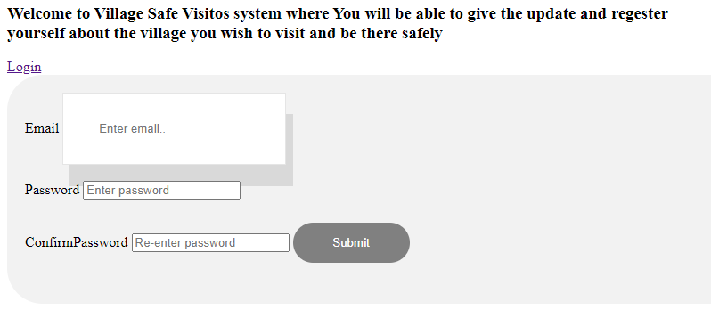

When User don’t have an account he will create it here and when he has account he will register himself directly

This how login looks like

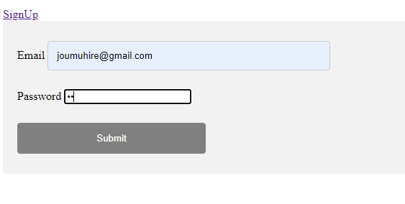

After Login user shoud register by filling information such as the current village where he live and where he is visiting and spend time there

This is how visitor Form

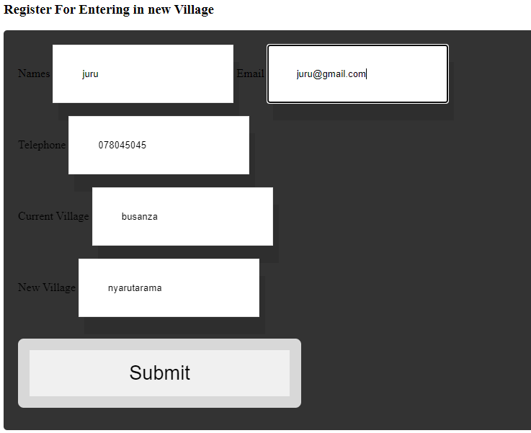

After Register himself user will be able to delete and update

This user update

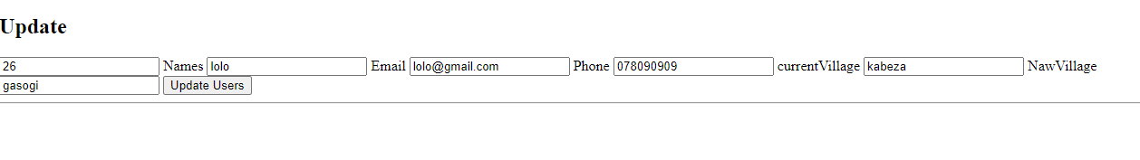

This is Delete

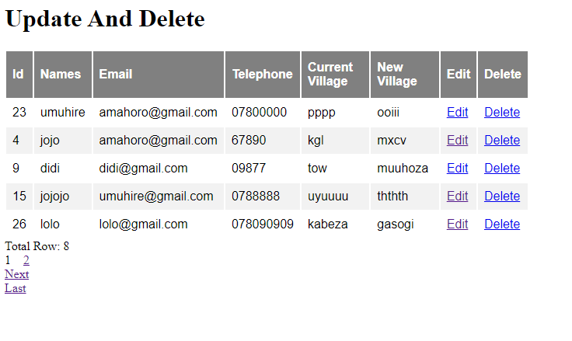

User should be able to delete and updated

There is also have pagination , when same one press 1 it will take you back and 2 will be back to normal

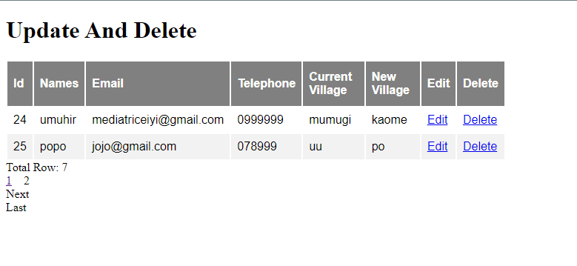

This Project will Satisfty a lot of Rwandan

Here are class diagram that has this Attribute of this project

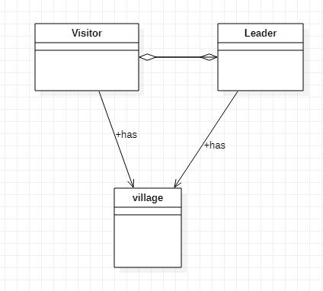

In this application I created Domain Model, Service Layer,Contrller layer and View Layer

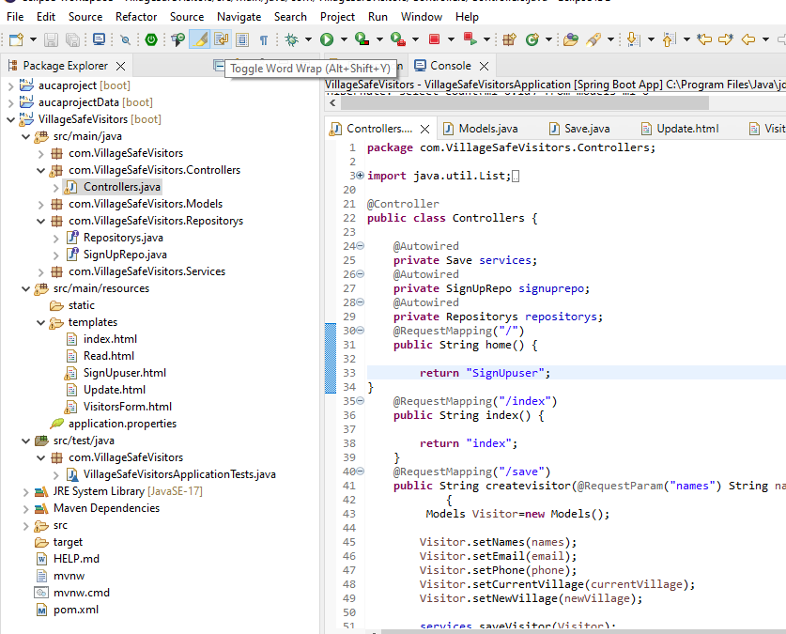

And POM also

